Today’s Date__________________
Name___________________________________________________DOB_____________________________
Emerg.Contact___________________________PH____________________Relationship_________________
I would like appt. reminders via (Circle One) TEXT E-MAIL VOICEMAIL
I give ________________________permission to discuss my appts., billing, and medical information with LRC.
Conditions and symptoms (check if you currently have or have had in the past)
- Anemia
- Arthritis (type & location) _________
- Asthma
- Bleeding disorders
- Bowel/Bladder dysfunction
- Cancer (location)________
- Chest pain
- Depression/ anxiety
- Diabetes: Type I II (circle)
- Emphysema
- Epilepsy / Seizures
- Fibromyalgia
- Headaches
- Heart Disease
- High Blood Pressure
- History of falls
- HIV/ Hepatitis C
- Irritable Bowel Syndrome
- Insomnia
- Irregular or rapid Heart Rate
- Pacemaker
- Pelvic Pain
- Problems with cognition/thinking
- Pregnant: Y N (circle)
- Smoker
- Stroke/ TIA
- Thyroid Disease
- Tuberculosis
- Ulcers
- Unexplained weight change
- Osteoporosis
- Other___________________________
________________________________
Please circle if you are experiencing any of the below symptoms:
Cough Fever/ Chills Nausea/ vomiting Drop Attacks
Chest pain Trouble breathing Visual changes Dizziness
Previous Surgeries/ injuries ______________________________________________________________
_____________________________________________________________________________________
Allergies______________________________________________________________________________
Medications___________________________________________________________________________

Name___________________________________________________DOB_____________________________
What are we seeing you for today? ________________________________________________________
1. Rate your pain by circling a number from 0-10 (0 is no pain, 10 is unbearable, emergency room pain)
A. At its worst, your pain level in the last 3 days was:
0 1 2 3 4 5 6 7 8 9 10
B. At this moment, your pain level is:
0 1 2 3 4 5 6 7 8 9 10
C. At its best, your pain level in the last 3 days was:
0 1 2 3 4 5 6 7 8 9 10
2. Circle the quality of your pain: Burning Sharp Dull/ Achy Throbbing Shooting Numbness/ Tingling (circle all that apply)
3. Is your pain: Constant Intermittent (circle one)
3. What makes your pain feel better? _____________________________________________________
4. What makes your pain feel worse? _____________________________________________________
5. Place an “X” where you are experiencing the most pain:
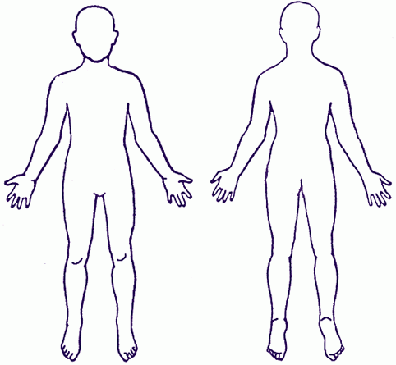

Name___________________________________________________DOB_____________________________
General Health (How would you describe your health?):
- Poor
- Fair
- Good
- Excellent

Mental and Personal Health (Check all that apply):
- Stress is a major problem for you
- During the past month, you have been bothered by feeling down, depressed, or hopeless
- During the past month, you have been bothered by little interest or pleasure in doing things
- Problems with eating or with your appetite
- Trouble sleeping
- Current psych therapy
Regular Exercise:
- Sedentary
- Mild Exercise
- Occasional vigorous exercise (< 3x a week for 30 minutes)
- Regular vigorous exercise (> 3x a week for 30 minutes)
Work Information:
Job Title: ______________________________________________________________________
Duties: ________________________________________________________________________
______________________________________________________________________________
Current Restrictions: _____________________________________________________________
What is/are your goal(s) for therapy?_______________________________________________________
_____________________________________________________________________________________
What are your interests/hobbies? _________________________________________________________
_____________________________________________________________________________________

Authorization for Release of Information
- I agree that LEADBETTER REHABILITATION CLINIC may provide information from my medical record to persons directly involved in my medical care via mail, text, secure fax or email.
- I authorize the release of medical information necessary to obtain payment of any benefits available to me to LEADBETTER REHABILITATION CLINIC for services rendered.
- I agree that LEADBETTER REHABILITATION CLINIC may obtain information from others who have provided medical care to me and/or are responsible for the payment of all or part of my bills when this information is needed only in order to treat, bill, and/or receive payment.
- I have been given a copy of Leadbetter Rehabilitation Clinic’s “Notice of Privacy Practices” as mandated by HIPAA.
Authorization for Release of Payment
- I authorize LEADBETTER REHABILITATION CLINIC to bill my insurance carrier for services rendered on my behalf
- I authorize that direct payment of any benefits available to me be released to LEADBETTER REHABILITATION CLINIC for services rendered.
Patient Agreement
- I agree to pay LEADBETTER REHABILITATION CLINIC charges for services rendered to me during my course of treatment.
- I agree to pay those charges which may not be paid by my health insurance and are my responsibility per my insurance benefits. If I fail to pay for charges that are my responsibility, I agree to pay LEADBETTER REHABILITATION CLINIC any costs associated with collecting these charges, including, but not limited to: collection agency costs, attorney and court fees.
Orthosis Fabrication/ Walk- In Splints
- I agree to pay LEADBETTER REHABILITATION CLINIC the charges not paid by my health insurance and are my responsibility per my insurance for any Orthosis/Splints that I receive.
Medicare, Medicaid, and Similar Benefits
- I agree that the information given to LEADBETTER REHABILITATION CLINIC in applying for benefits under Medicare, Medicaid, and Maternal or Child Health services are complete and accurate. I agree that LEADBETTER REHABILITATION CLINIC may give Social Security Administration or its fiscal intermediaries information necessary to process claims.
Workers Compensation
- I agree that the information given to LEADBETTER REHABILITATION CLINIC in applying for benefits under Workers Compensation is complete and accurate. I agree that LEADBETTER REHABILITATION CLINIC may give intermediaries information necessary, including private health information, to process claims. I understand that if my Workers Compensation benefits are denied, that I am responsible for the payment of the charges from services rendered. I understand that it is my responsibility to provide LEADBETTER REHABILITATION CLINIC with accurate information regarding other insurance coverage.

_________________________________________________________________________________
Printed Patient Name DOB

_________________________________________________________________________________
Patient Signature /Legal Representative/Guarantor Date

